

Go2FA User Manual V1.0

(COMPUTER)

Project Team: SS18/1F

Produced by: Koh Hong Wei (5363536)

Chua Han Ming Adler (5710923)

Ong Wei Hao (5711356)

Supervisor: Dr Ta Nguyen Binh Duong

Contents

1. Introduction 3

2. Requirements 4

3. Register Account 5

4. Log In 6

5. Main Menu 7

5.1. Lock 8

5.2. Unlock 11

5.3. View File 14

5.4. View History 15

5.4.1 View File History by Date 16

5.4.2 View Login History by Date 17

6. Change Password 18

# 1. Introduction

Welcome to **go2FA User Manual (COMPUTER)**. The objective of this document is to allow user to understand the functionalities of go2FA application on both Windows and Macintosh. This is a step by step user guide to ensure smooth usage of our application.

# 2. Requirements

|  |  |  |
| --- | --- | --- |
| Recommended System Requirements | | |
|  | Windows | Macintosh |
| Connectivity | Wi-Fi 802.11 a/b/g/n/ac) | Wi-Fi 802.11 a/b/g/n/ac) |
| Operating System | Windows OS (e.g. Windows XP,  Windows Vista, Windows 7, Windows 10) | * Mac OS (e.g. Mac OS X or above) |
| RAM | 1GB | 1GB |

# 3. Register Account

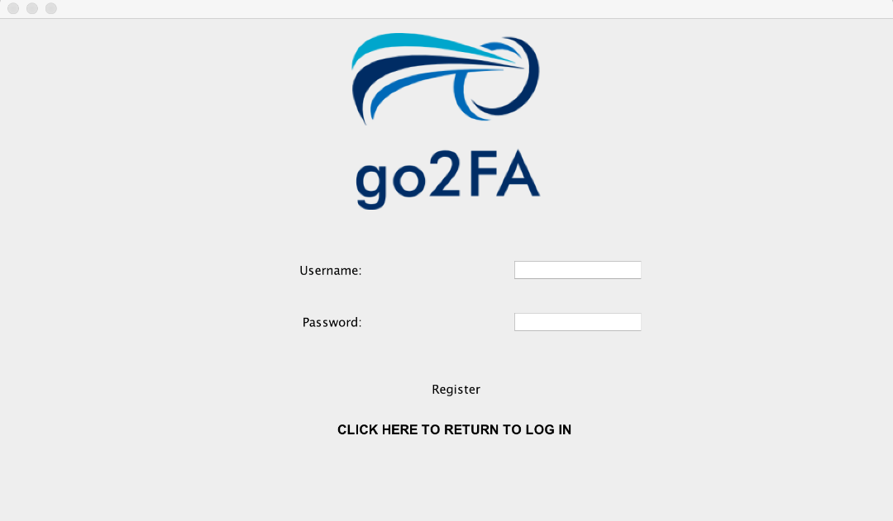

This is the Register Account page for Windows and Macintosh OS.

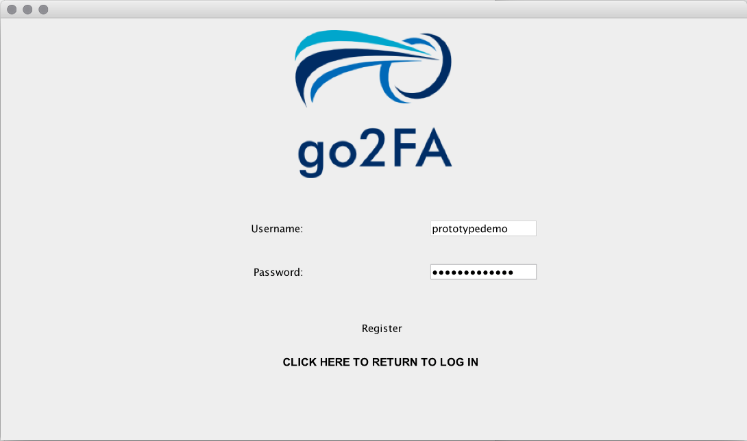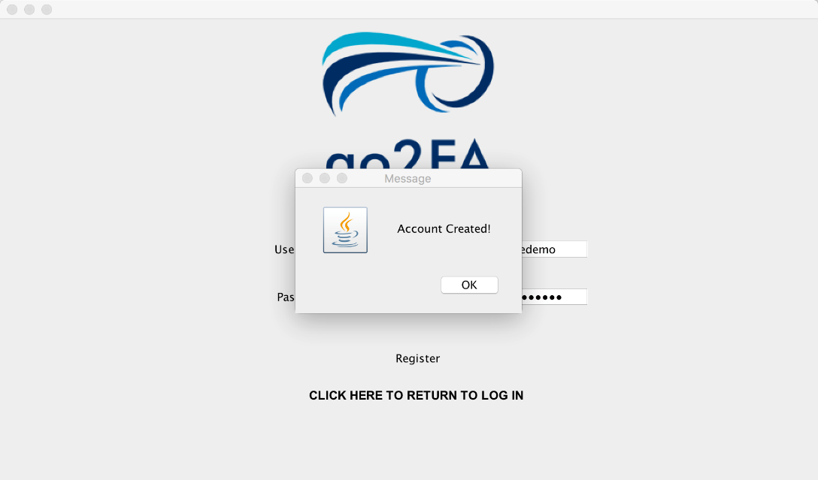

Upon entering the desire Username and Password for account registration, a prompt will appear indicating that the account has been created successful.

# 4. Log In

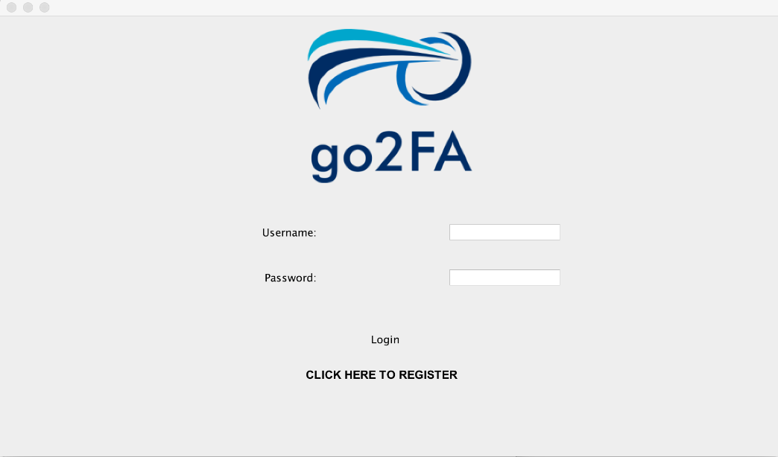

This is the log in page when the application is launch, simply key in the Username and Password that has been created to use our system.

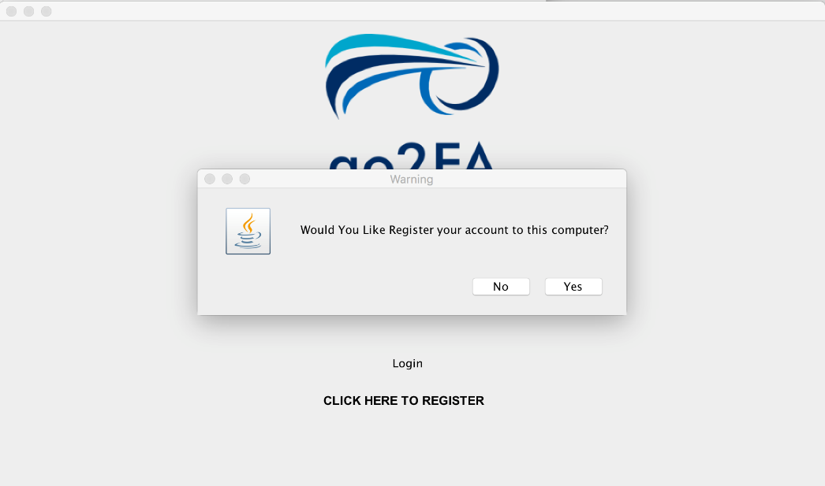

When successful logged in, system will prompt a message indicating if you would like to register your account to this computer.

Note that if your account is tagged to a computer, your account cannot be used on another computer that isn’t registered as one account can only be tagged to one computer.

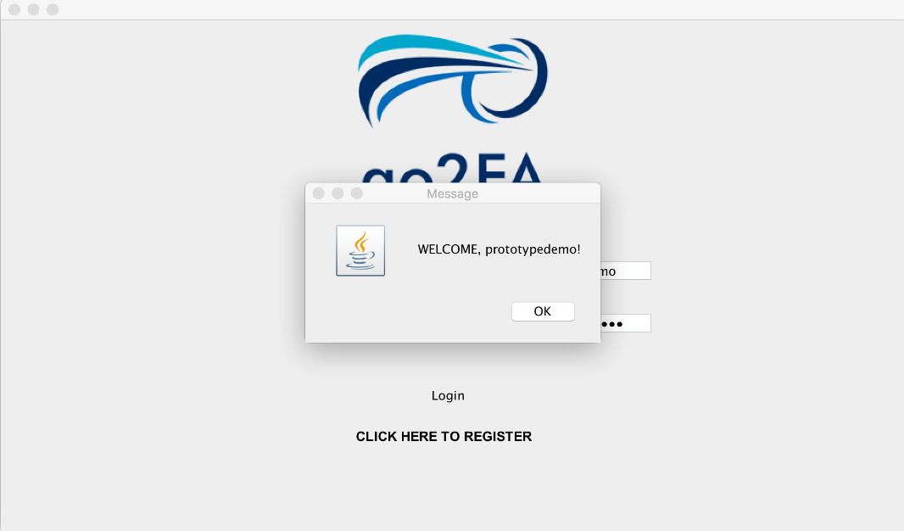

A welcome message will be displayed when you have successful logged into our system.

# 5. Main Menu

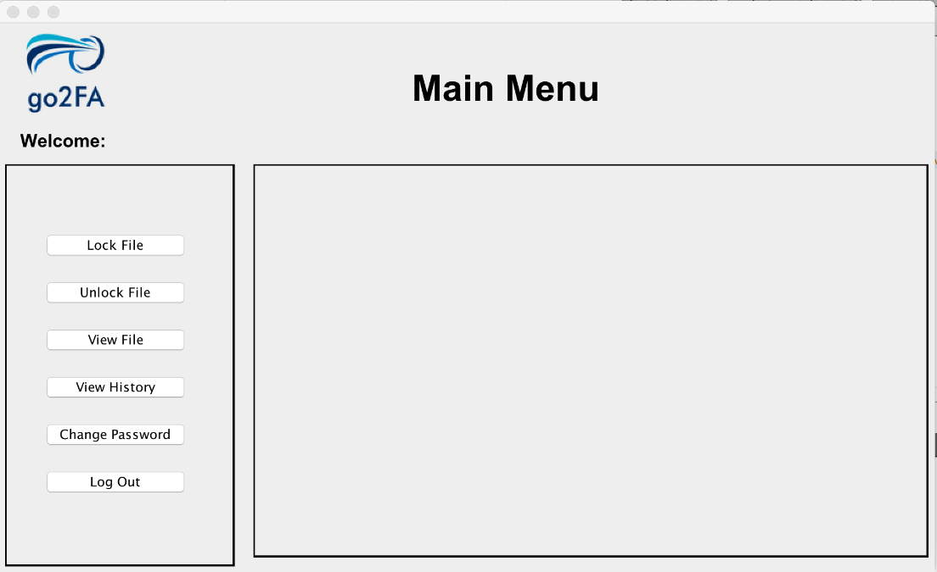

After logging in, welcome to our application’s main menu. This is where you can select functions provided by our application to help protect your files.

## 5.1. Lock

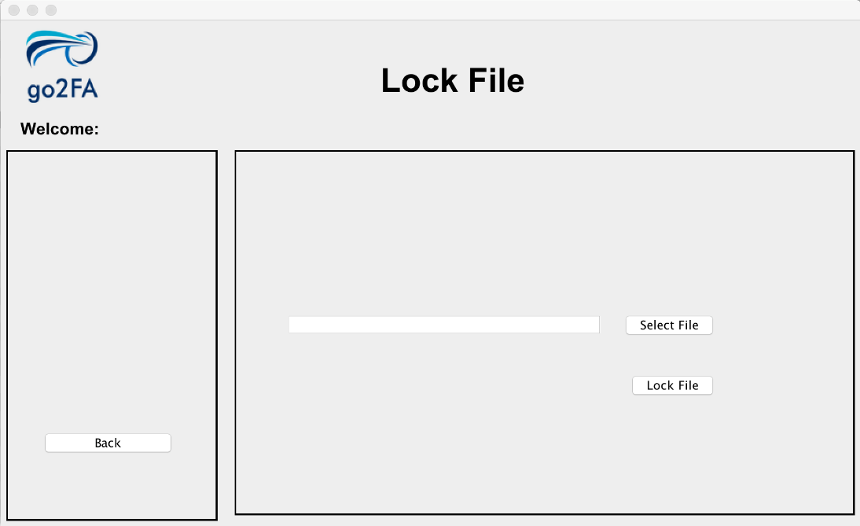

This page will appear when you select our LOCK function. This page lets you select file from a directory in your computer which you want to secure and lock.

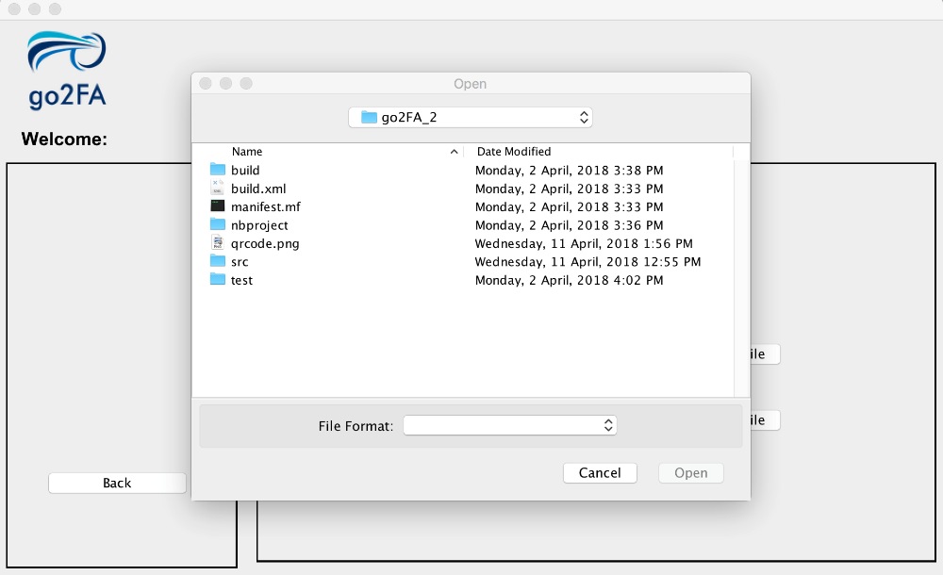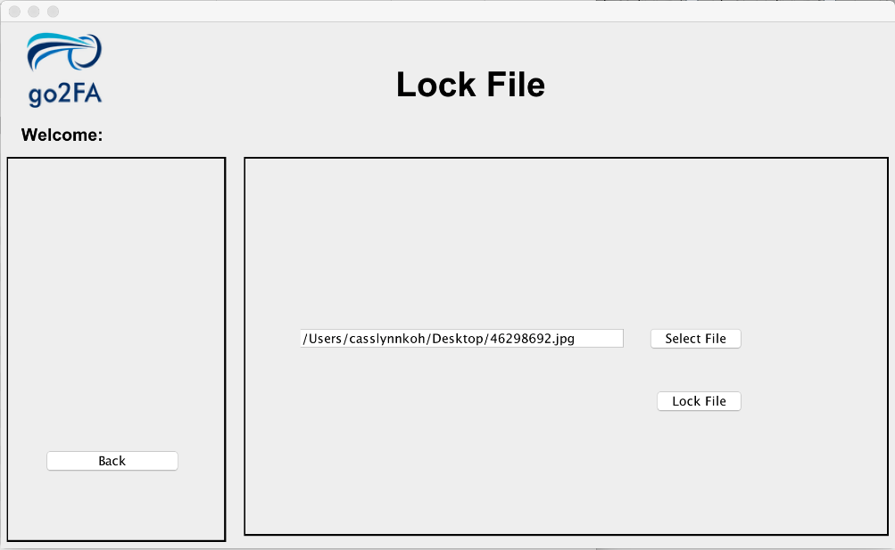

As you can see from the images on the left, you can select individual file in your selected directory

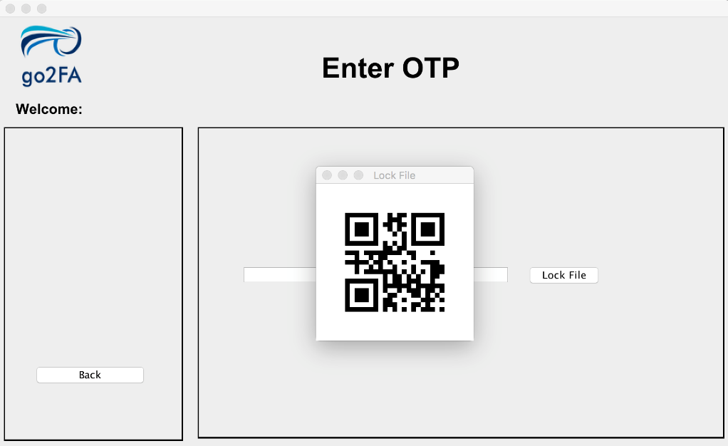

After you decided to lock the file in your path directory, a QRCode will appear and this is when you will need our mobile application to generate the OTP using the scanner.

The OTP in the QRCode is cryptographically secured and can only be decrypted using our mobile application scanner.

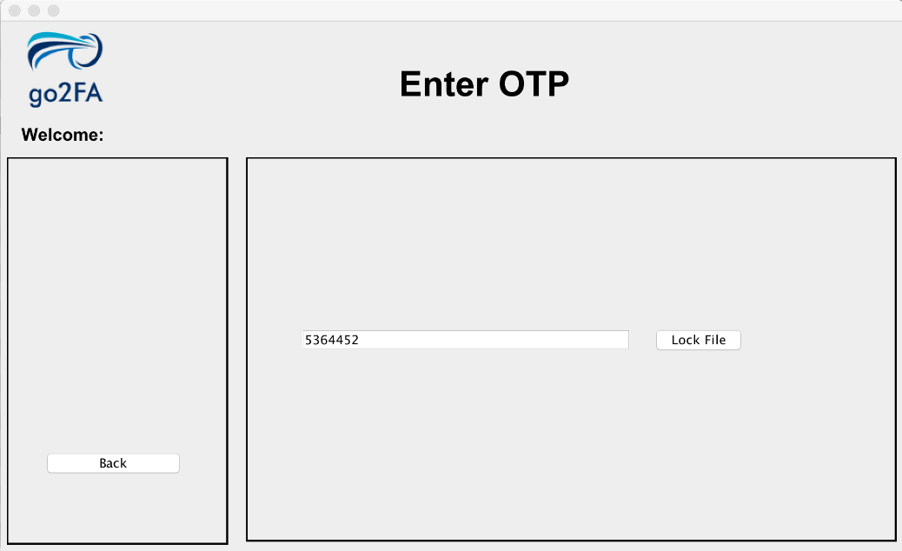

Enter the OTP that is generated from the scanner on our mobile application

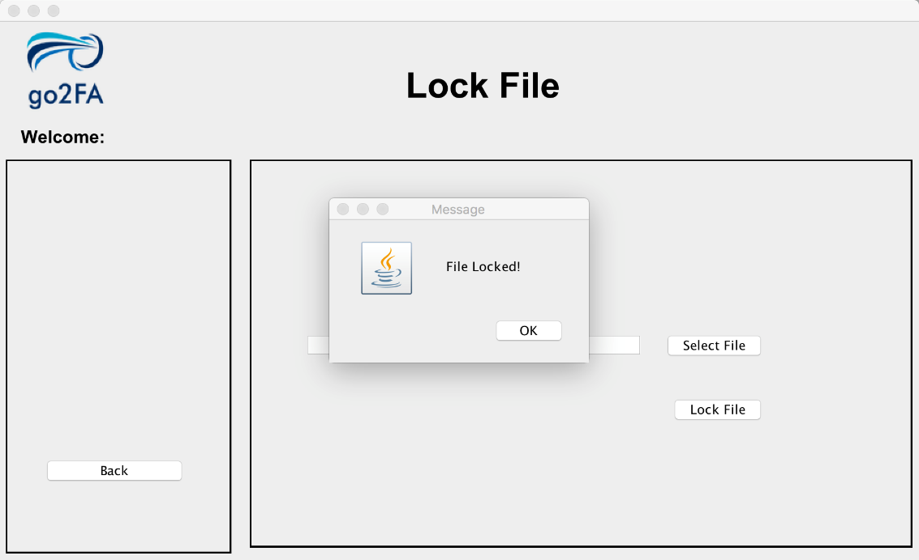

Your file will be lock in our system successfully.

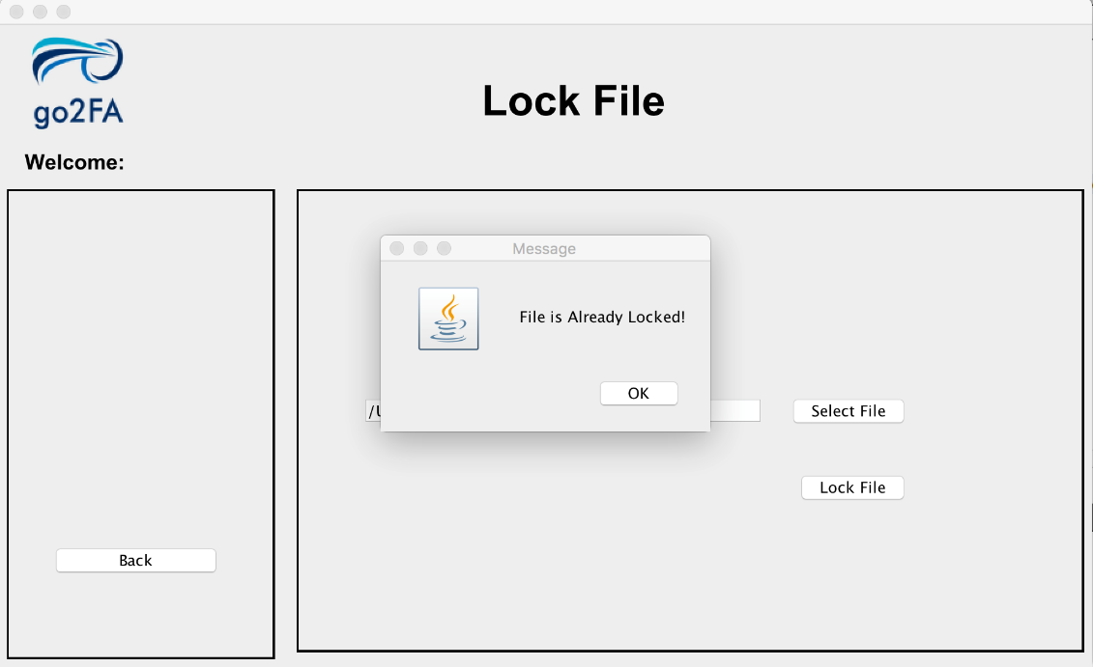

If you happen to lock a same file in our system, fret not, a message will be prompted to you indicating that the file you want to lock has already been locked.

## 5.2. Unlock

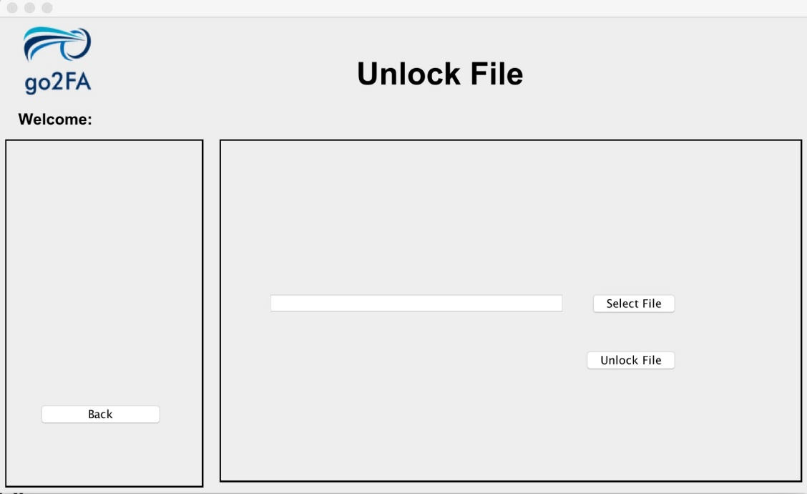

This page will appear when you select our UNLOCK function. This page lets you select file from a directory in your computer which you want to unlock securely.

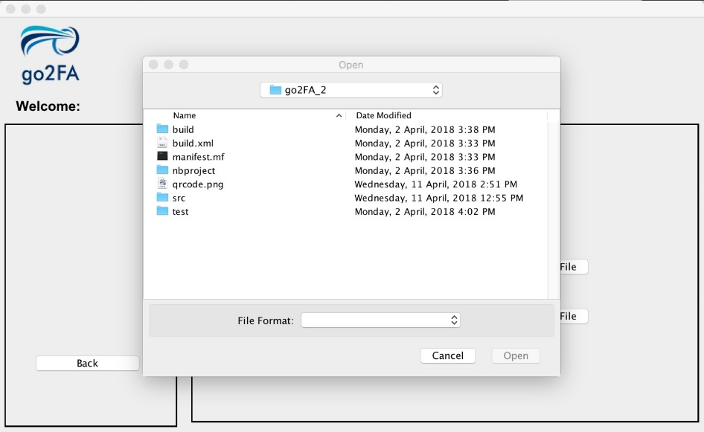

As you can see from the images on the left, you can select individual file in your selected directory

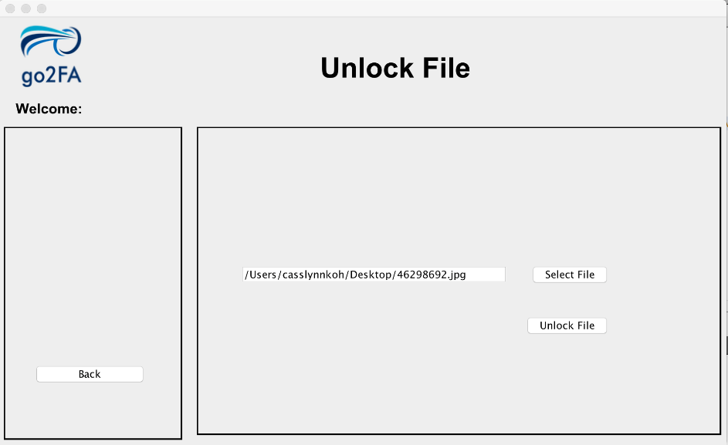

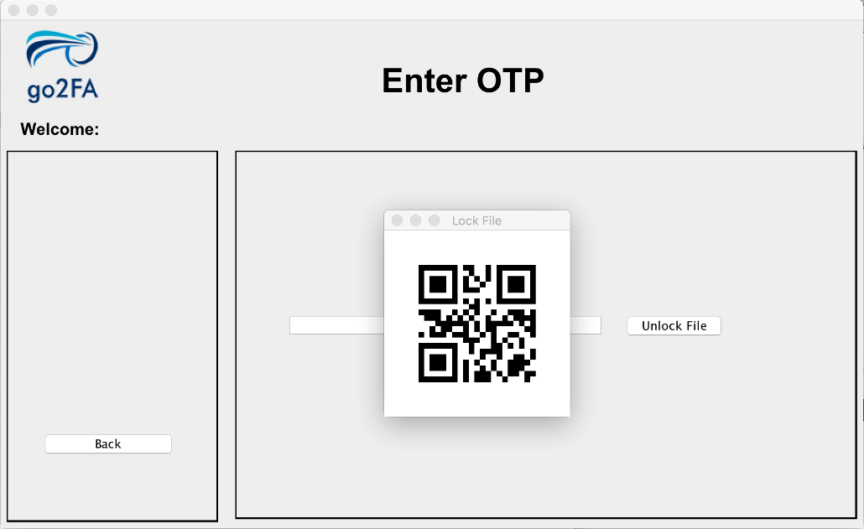

After you decided to unlock the file in your path directory, a QRCode will appear and this is when you will need our mobile application to generate the OTP using the scanner.

The OTP in the QRCode is cryptographically secured and can only be decrypted using our mobile application scanner.



Enter the OTP that is generated from the scanner on our mobile application

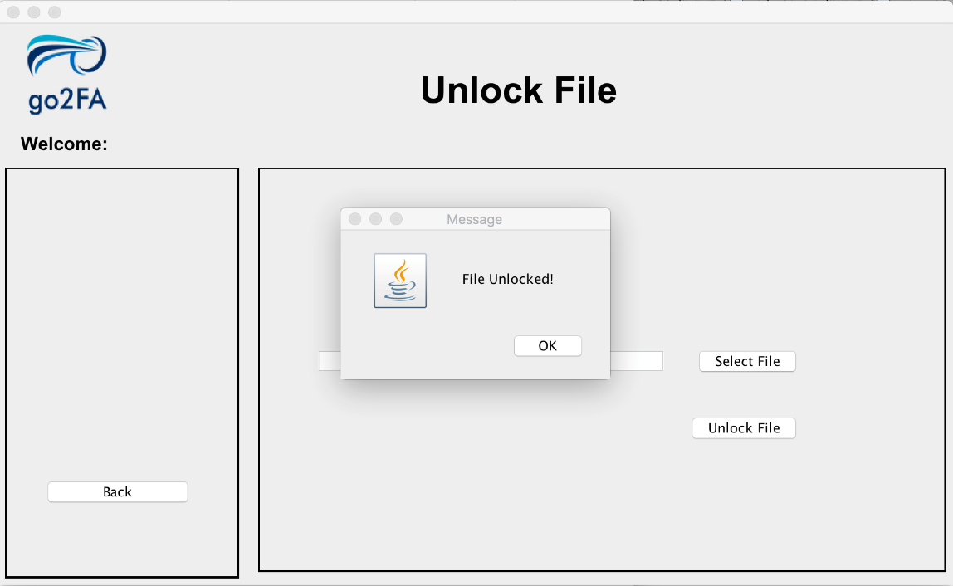

Your file will be unlocked by our system successfully.

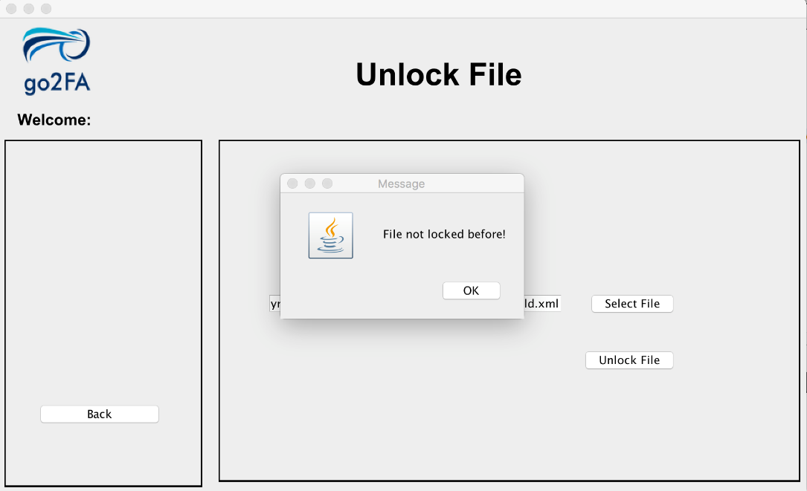

If you happen to unlock a same file in our system, fret not, a message will be prompted to you indicating that the file you want to unlock has not been locked.

## 5.3. View File

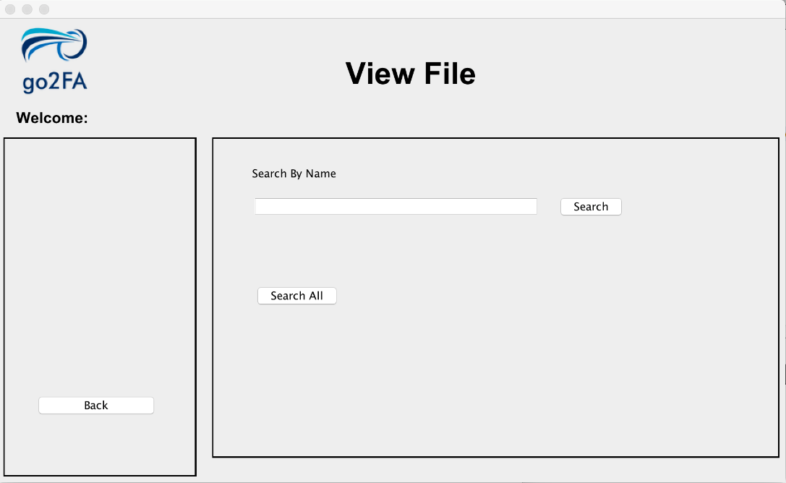

This page will appear when you select our VIEW FILE function. This page lets you search for the status of a file by name.

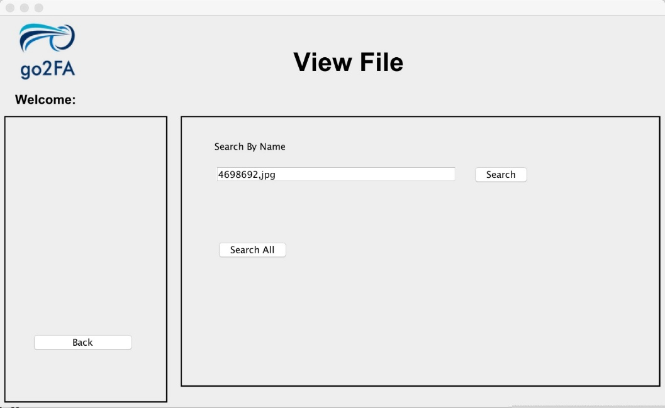

Enter the name of the file you want to search

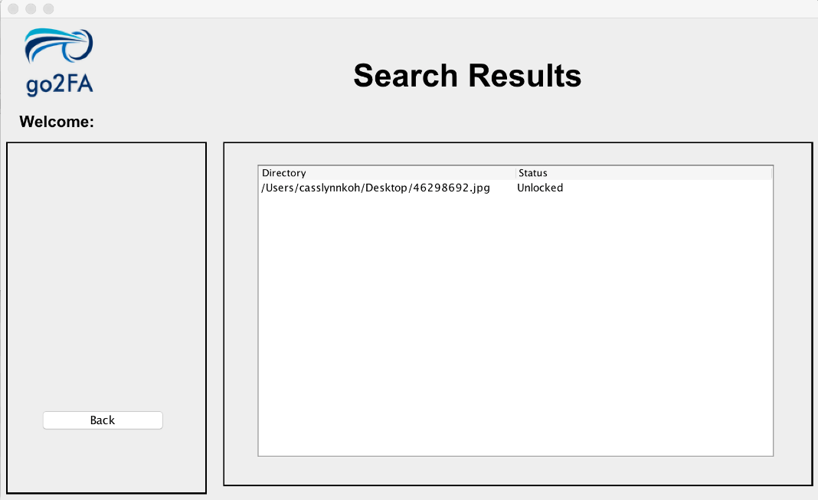

When the name of the file is valid, the search result will be shown indicating the file directory and the status.

## 5.4. View History

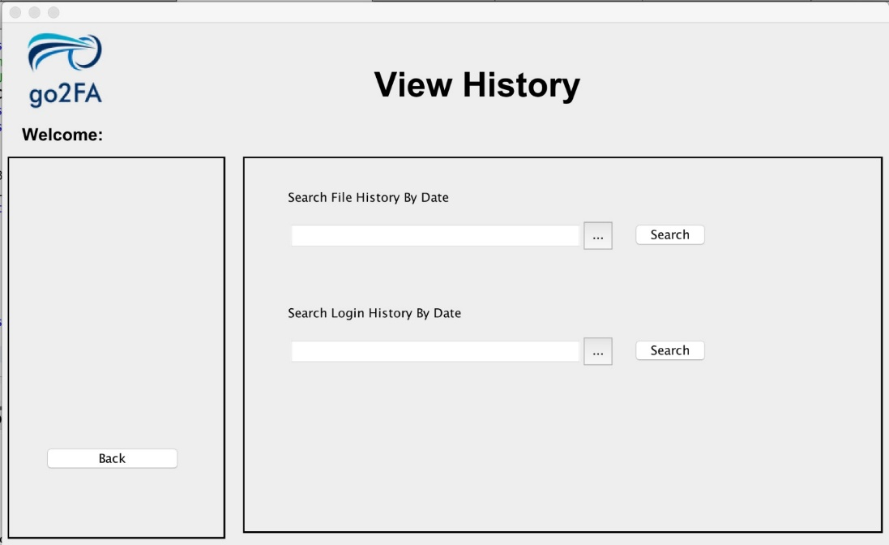

This page will appear when you select our VIEW HISTORY function. This page lets you search for file histories and login histories by date

### 5.4.1 View File History by Date

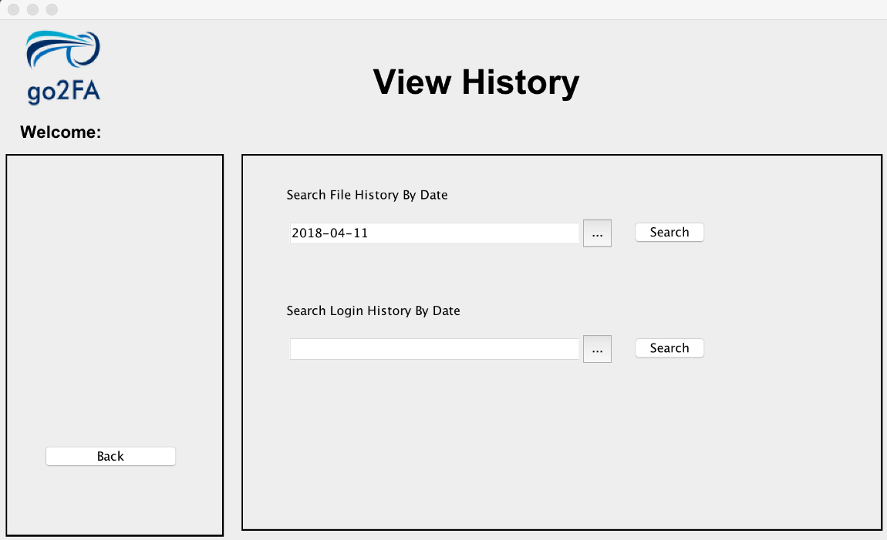

Using the drop-down calendar, you can select the dates you want to search the files by.

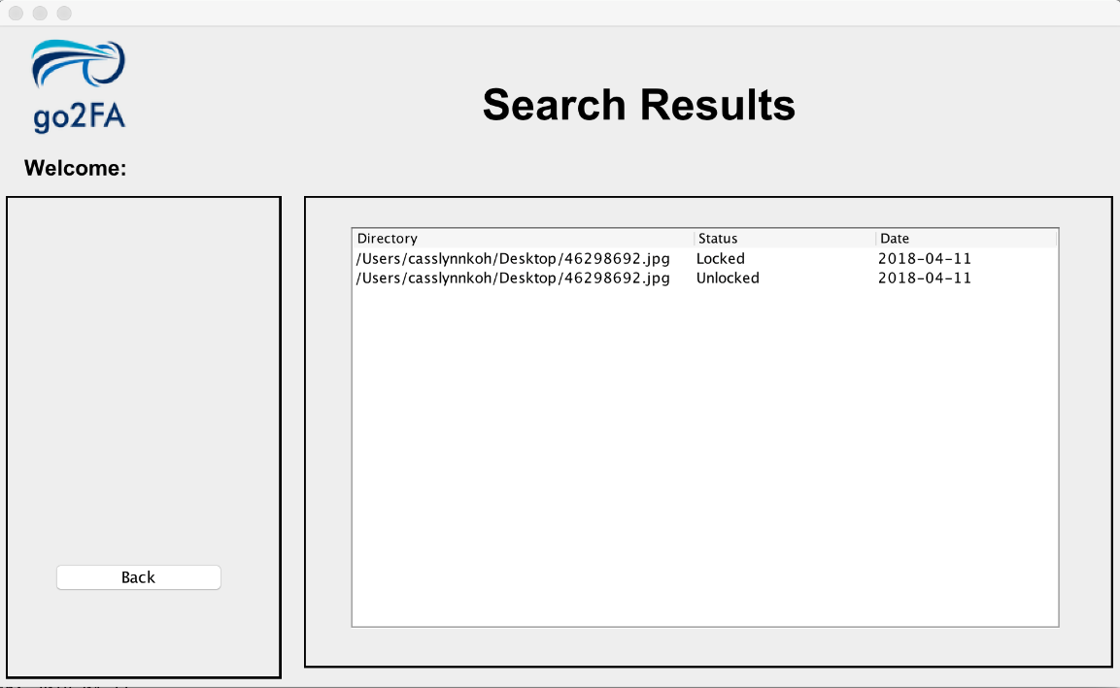

After selecting the dates successful, the search results will appear and indicating the actions done on files on the dates.

### 5.4.2 View Login History by Date

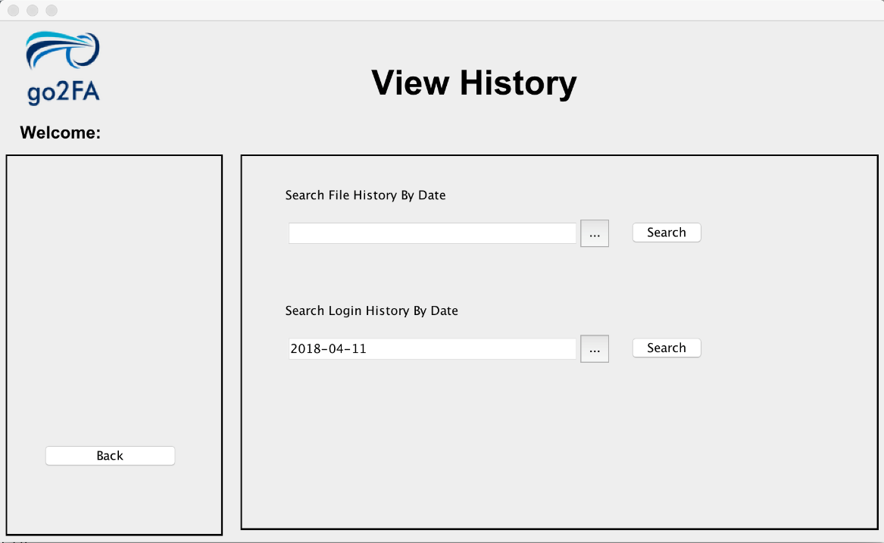

Using the drop-down calendar, you can select the dates you want to search the login histories done by your account.

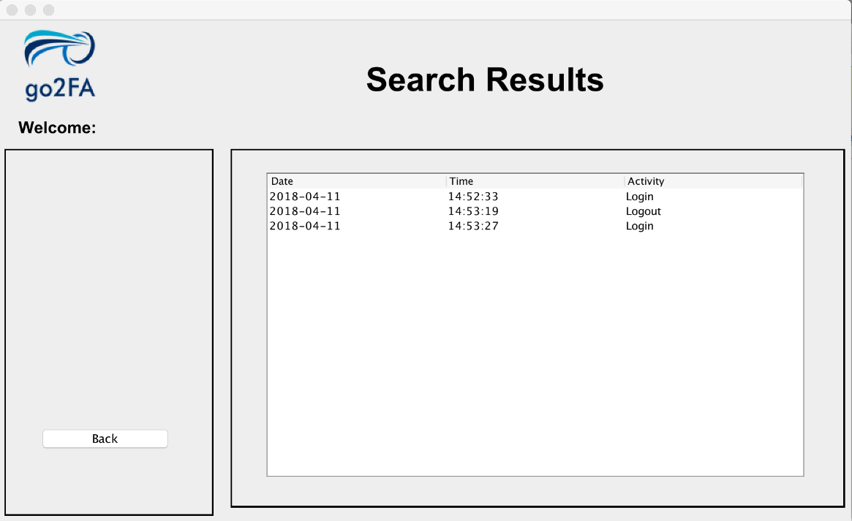

After selecting the dates successful, the search results of your past logins and logouts will appear.

# 6. Change Password

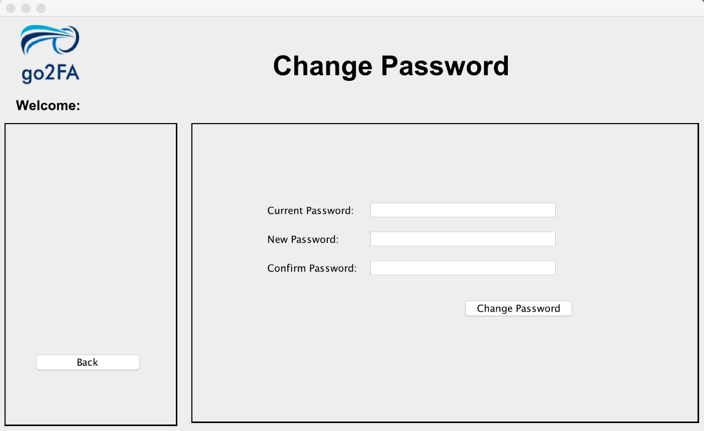

This page will appear when you select our CHANGE PASSWORD function. This page lets you change your existing password to a new desired password.

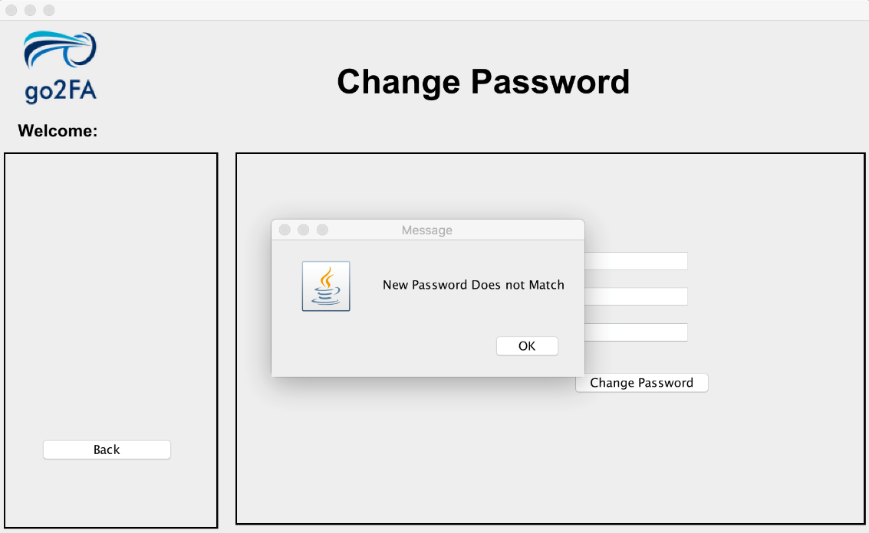

If the password you entered for the new password and confirm password does not match, a prompt message will appear indicating the mismatch and your password will not be changed.

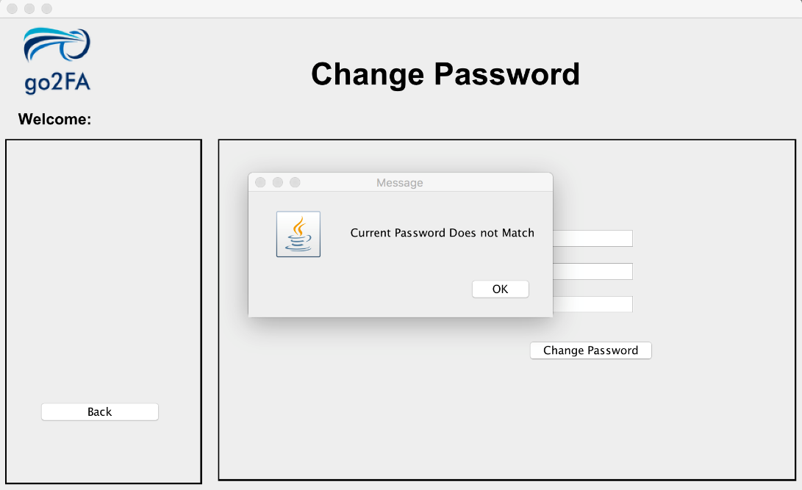

If the password you entered for the current password does not match with the record on our database, a prompt message will appear indicating the mismatch and your password will not be changed.

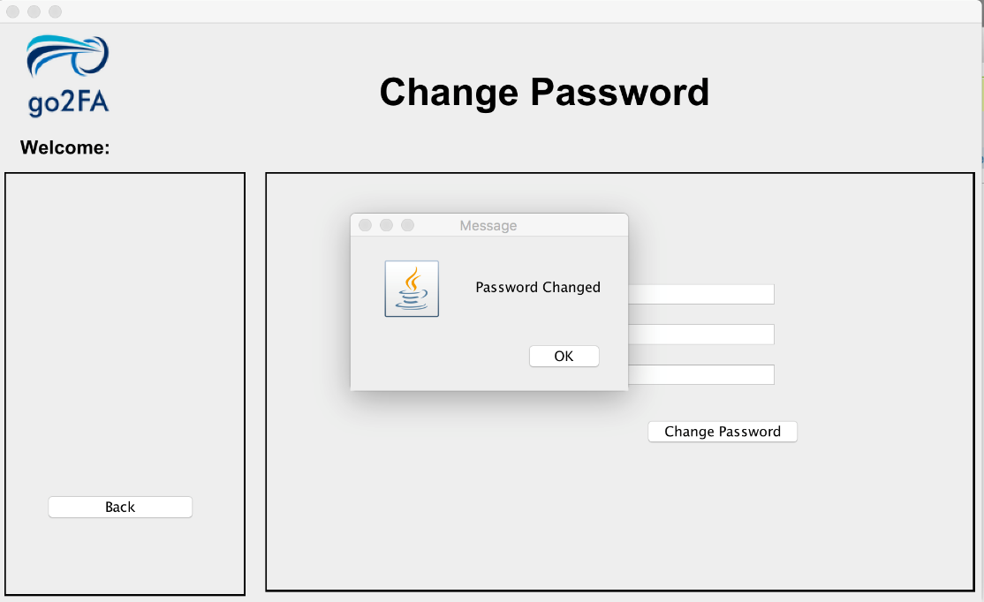

When you entered the password credentials correctly, your password will be successfully changed and updated in our database.